Order of Gonad Development Assay
Date：
NO.: 20230
- Information from the client
Table 1 Information from the client
Name: |  | Institute/ university:
PI (If different from above): |  | Department：
Tel: |  | E-mail:
Delivery Address:
Billing Address (If different from above):
Is the client willing to share his/her name, lab, and email address with SUNY’s future clients if they inquire? _______
How did the client learn about SunyBiotech? _________
- Email B) Mail C) Website D) From colleagues or friends
- Other
(If the client chooses D, please write down the referrer name and institute and SUNY will apply 5% OFF to both the client and the client’s referrer. But please kindly note the 5% OFF is only applicable when the referrer comes from other labs.)
- About this assay
The purpose of this assay is to analyze the gonad development of C. elegans after the treatment of drugs with different concentration. For every concentration, one/three replicate(s) will be conducted. For every/three replicate(s), the data of 10/30 worms will be provided.
- Information about the tested strains
  - Please complete the strain information including strain name, genotype, phenotype and culture condition in the below Table 2.
  - If the clients want to treat the worms with specific drugs, please complete the Table 3.
  - Please send all strains/drugs to Sunybiotech. If client’s wild type N2 strain is used as control, please also include the wild type N2 strain when sending strains to SUNY.
  - Is the drug sterilized or not? ( for example: yes, no). If not, please provide the sterilization method . If the syringe driven filtration is required, please choose the pore size of the syringe driven filter (0.22µm or 0.45µm).
  - The drug should be added into for C. elegans culturing. (for example: NGM, OP50).
Table 2 Information about the strains
Strain name | Genotype | Phenotype | Culture condition
N2
Table 3 Information about the drugs
 | Drug name/ NO. | Concentration of the stock | Storage condition | Solvent | working concentration
1
2
3
4
5
- Method/ protocol
Prepare the experimental reagents
  - Prepare 0.5% Cholesterol solution with absolute ethanol as the solvent.
  - Prepare sterilized K solution: add 2.386 g potassium chloride and 2.98 g sodium chloride in 1000 mL deionized water, and then sterilize.
  - K+ solution: 0.33 g calcium chloride, 2.38 g potassium chloride, 0.36 g magnesium sulfate, 2.98 g sodium chloride were added to 1000 mL deionized water and sterilized.
  - Prepare the NGM plates with OP50 seeded.
Prepare synchronized animals
  - Prepare the synchronized eggs by collecting eggs from adults in one hour, culture the eggs in the 20 °C incubator.
  - The drugs treatment begins at L4 ? stage for 24h ? .
DAPI staining and imaging
  - When worms grow to young adult stage, conduct the DAPI staining, and take the pictures of the worms as previously described ^{[1]}.
  - Photographing the gonad of worms in the DAPI channel.
Representative results
  - The raw data of the photos of all worms (Figure 1).
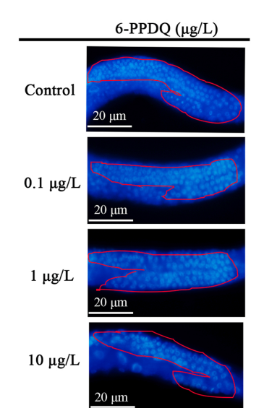
Figure 1 Images of gonad of DAPI staining ^{[1]}

- Duration and Cost of the service
  - SUNY will conduct the gonad development assay after get well cultured clean animals. Usually 2-3 weeks is enough. SUNY will inform client when SUNY begin and finish the assay.
  - The price of one/ three replicate(s) is $250 / $600 for every strain/treatment. The final price would be for strains/treatments with replicate(s).
  - SUNY will start the experiment after the client confirms the order. If the client needs to modify any order that has already been confirmed and started production, this may incur an additional charge.
- Products SUNY provide
  - The raw data of the photos of all worms.
- How and when to pay
  - T/T (Telegraphic Transfer)
  - If it is client’s first time placing an order with SUNY and the total amount is no more than 3000 USD, no pre-payment is required. Otherwise, SUNY will require a pre-payment that equals to 50% of the total amount of client’s order prior to providing the service.
- Reference
[1] Xin Hua , Xiao Feng, Geyu Liang, Jie Chao, Dayong Wang. Long-term exposure to 6-PPD quinone reduces reproductive capacity by enhancing germline apoptosis associated with activation of both DNA damage and cell corpse engulfment in Caenorhabditis elegans. Journal of Hazardous Materials.2023.454: 131495.
[2]Qu M, Qiu Y, Kong Y, Wang D. Amino modification enhances reproductive toxicity of nanopolystyrene on gonad development and reproductive capacity in nematode Caenorhabditis elegans. Environ Pollut. 2019 Nov;254(Pt A):112978.

