Order of Quantitative Analysis of DA neurons
Date：
NO.:
- Information from the client
Table 1 Information from the client
Name: |  | Institute/ university:
PI (If different from above): |  | Department：
Tel: |  | E-mail:
Delivery Address:
Billing Address (If different from above):
Is the client willing to share his/her name, lab, and email address with SUNY’s future clients if they inquire?
How did the client learn about SunyBiotech? _________
- Email B) Mail C) Website D) From colleagues or friends
E) Other
- About this assay
The purpose of this assay is to count the number of DAergic neurons of worms. For every strain, one/three replicate(s) will be conducted. For every/ three replicate(s), at least 50/ 150 worms will be tested.
- Information about the tested strains
  - Please complete the strain information including strain name, genotype, phenotype and culture condition in the below Table 2.
  - If the clients want to treat the worms with specific reagents, please complete the Table 3. The reagents will be added in to the NGM solution before make the NGM plate.
  - Please send all strains/ reagents to SUNY. If client’s wild type N2 strain is used as control, please also include the wild type N2 strain when sending strains to SUNY.
  - Is the drug sterilized or not? ( for example: yes, no). If not, please provide the sterilization method . If the syringe driven filtration is required, please choose the pore size of the syringe driven filter (0.22µm or 0.45µm).
  - The drug should be added into for C. elegans culturing. (for example: NGM, OP50).
Table 2 Information about the strains
Strain name | Genotype | Phenotype | Culture condition
PHX9354 | sybIs8298[dat-1p::GFP] | Bright GFP observable in dopamine neuronal soma and processes | 20℃
PHX9264 | sybIs8291[dat-1p::GFP & dat-1p::α-synuclein] | Dopaminergic neuron damage | 20℃
Table 3 Information about the reagents
 | Drug name/ NO. | Concentration of the stock | Storage condition | Solvent | working concentration
1

2
3
4
5
- Method/ protocol
Prepare NGM plates
  - Prepare typical NGM plate and NGM plate with drug of different concentrations with or without FUDR.
  - Prepare the NGM plates with OP50 seeded.
Prepare synchronized animals
  - Prepare the synchronized eggs by collecting eggs from adults in one hour on the NGM plates, culture the eggs in the 20 °C incubator.
  - The drug treatment begins at L4 ? or L1? stage.
Observe and count the number of DAergic neurons
  - Transfer the worms to new NGM plates with FUDR and drug (after L4) every 96 hours to avoid starve and contamination.
  - days later, observe and count the number of DAergic neurons.
  - Take two pictures of worms with typical phenotype using the same exposure time in the GFP channel.
Representative results
  - The raw data of the number of DAergic neurons (Figure 1).
  - Two picture of worms with typical phenotype (Figure 2).
  - The statistic data of different treatments (Figure 3)
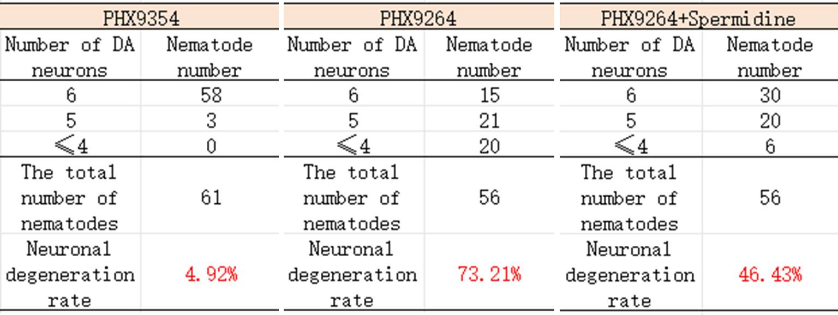
Figure 1 The raw data of the number of DAergic neuron
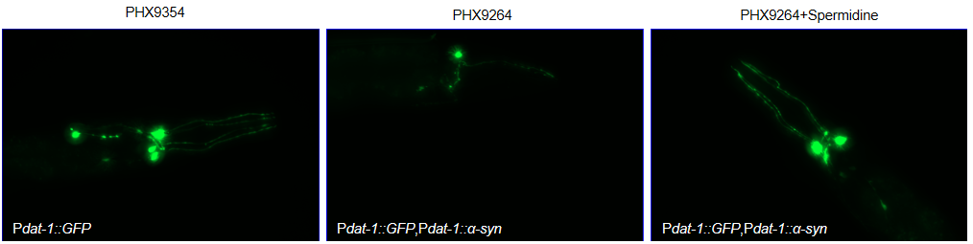
Figure 2 The fluorescence of the DAergic neurons
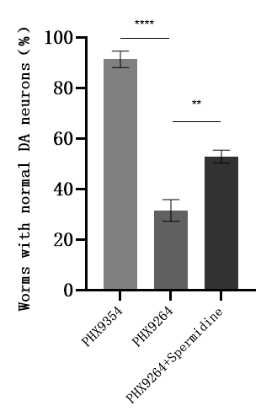
Figure 3 The statistic analysis of the worms with normal DA neurons
- Duration and Cost of the service
  - SUNY will conduct the DAergic neurons measurement assay after SUNY get well cultured clean strains. The duration time is about 3-4 weeks as it will take at least one week to culture the starved worms for assay.
  - The price of one/ three replicate(s) is $350 / $800 respectively for every strain/treatment when counting is on the day 8. The final price would be $ for strains/ treatments for replicate(s).
  - SUNY will start the experiment after the client confirms the order. If the client needs to modify any order that has already been confirmed and started production, this may incur an additional charge.
- Results SUNY provide
  - The raw data of the number of DAergic neurons.
  - Two picture of worms with typical phenotype.
  - The statistic data of different treatments.
- How and when to pay
  - T/T (Telegraphic Transfer)
  - If it is client’s first time placing an order with SUNY and the total amount is no more than 3000 USD, no pre-payment is required. Otherwise, SUNY will require a pre-payment that equals to 50% of the total amount of client’s order prior to providing the service.
- Reference
- Chalorak P, Sornkaew N, Manohong P, Niamnont N, Malaiwong N, Limboonreung T, Sobhon P, Aschner M, Meemon K. Diterpene glycosides from Holothuria scabra exert the α-synuclein degradation and neuroprotection against α-synuclein-Mediated neurodegeneration in C. elegans model. J Ethnopharmacol. 2021 Oct 28;279:114347. doi: 10.1016/j.jep.2021.114347. Epub 2021 Jun 17. Erratum in: J Ethnopharmacol. 2023 Jan 30;301:115844. PMID: 34147616; PMCID: PMC8381228.

